PROJECT REPORT
Laravel Blog Management System

Developed By: MD. MOKLAASUR RAHAMAN
Email: rahat830611@gmail.com
Batch: WDF-1
Technology Stack: Laravel 11/12, Tailwind CSS, MySQL
Date: ____/_____/_______

Introduction
This project is a modern blogging platform developed using the Laravel framework. It provides a comprehensive solution for managing blog posts, categories, tags, and user profiles. The system is designed with a focus on usability, security, and a clean user interface using Tailwind CSS.

Core Features:
- Authentication (Login, Register, Password Reset).
- Post CRUD operations with status management (Draft/Published).
- Dynamic Category and Tagging system.
- User Profile and Security settings.
- Relational Database architecture.

Home Page Interface
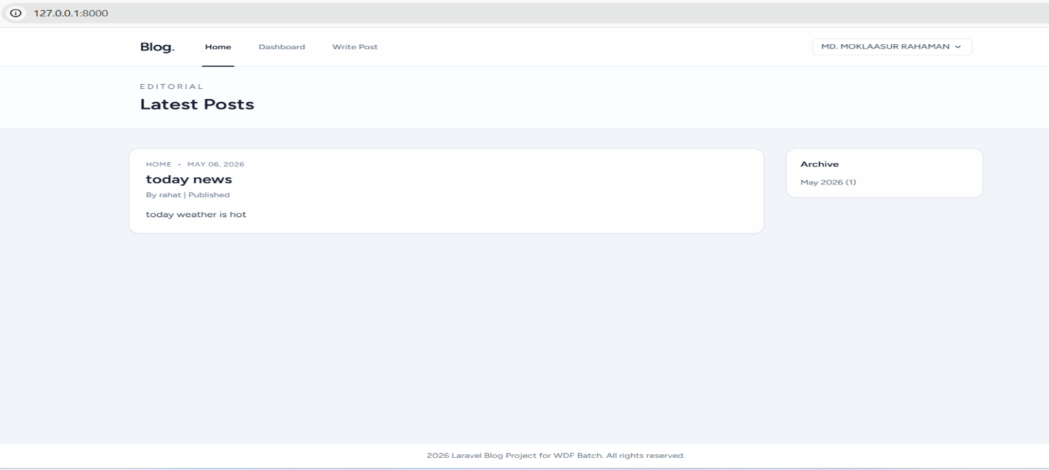
Implementation Code:
The Home Page fetches published posts and organizes them with an archive list.
// PostController.php
public function index() {
$posts = Post::published()->with(['user', 'category'])->latest()->paginate(10);
$archives = Post::published()->selectRaw('YEAR(published_at) year...')-
>
groupBy('year')->get();
return view('posts.index', compact('posts', 'archives'));
}

User Dashboard
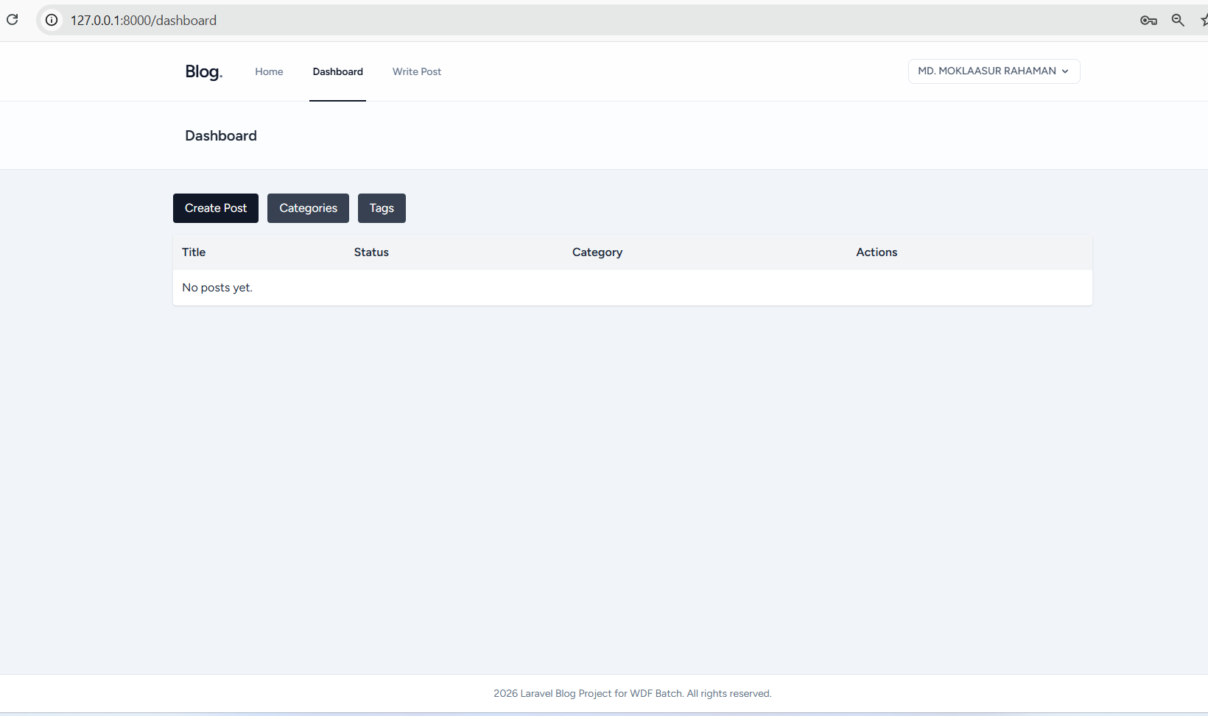
Logged-in users can manage their content through this private dashboard.
// DashboardController.php
public function index() {
$posts = auth()->user()->posts()->latest()->paginate(10);
return view('dashboard.index', compact('posts'));
}

Add Category
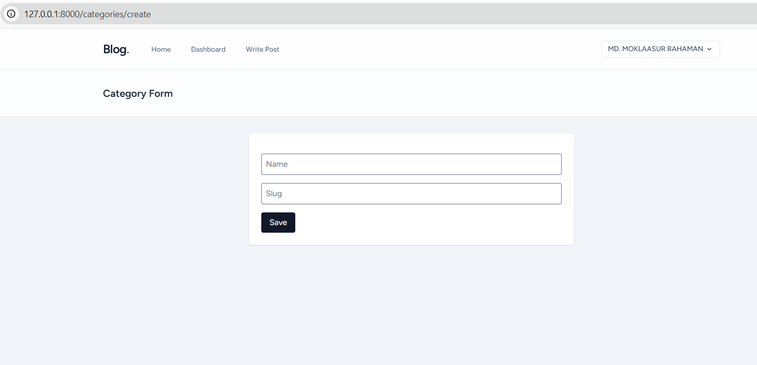

Implementation Code:
<?php

namespace App\Http\Controllers;

use App\Models\Category;
use Illuminate\Http\Request;
use Illuminate\Support\Str;

class CategoryController extends Controller
{
public function index()
{
return view('categories.index', [
'categories' => Category::latest()->paginate(15),
]);
}

public function create()
{
return view('categories.create');
}

public function store(Request $request)
{
$data = $request->validate([
'name' => ['required', 'string', 'max:255', 'unique:categories,name'],
'slug' => ['nullable', 'string', 'max:255', 'unique:categories,slug'],
]);

$data['slug'] = $data['slug'] ?? Str::slug($data['name']);
Category::create($data);

return redirect()->route('categories.index')->with('success', 'Category created successfully.');
}

public function edit(Category $category)
{
return view('categories.edit', compact('category'));
}

public function update(Request $request, Category $category)
{
$data = $request->validate([
'name' => ['required', 'string', 'max:255', 'unique:categories,name,' . $category->id],
'slug' => ['nullable', 'string', 'max:255', 'unique:categories,slug,' . $category->id],
]);

$data['slug'] = $data['slug'] ?? Str::slug($data['name']);
$category->update($data);

return redirect()->route('categories.index')->with('success', 'Category updated successfully.');
}

public function destroy(Category $category)
{
$category->delete();

return redirect()->route('categories.index')->with('success', 'Category deleted successfully.');
}
}

Content Creation (Create Post)
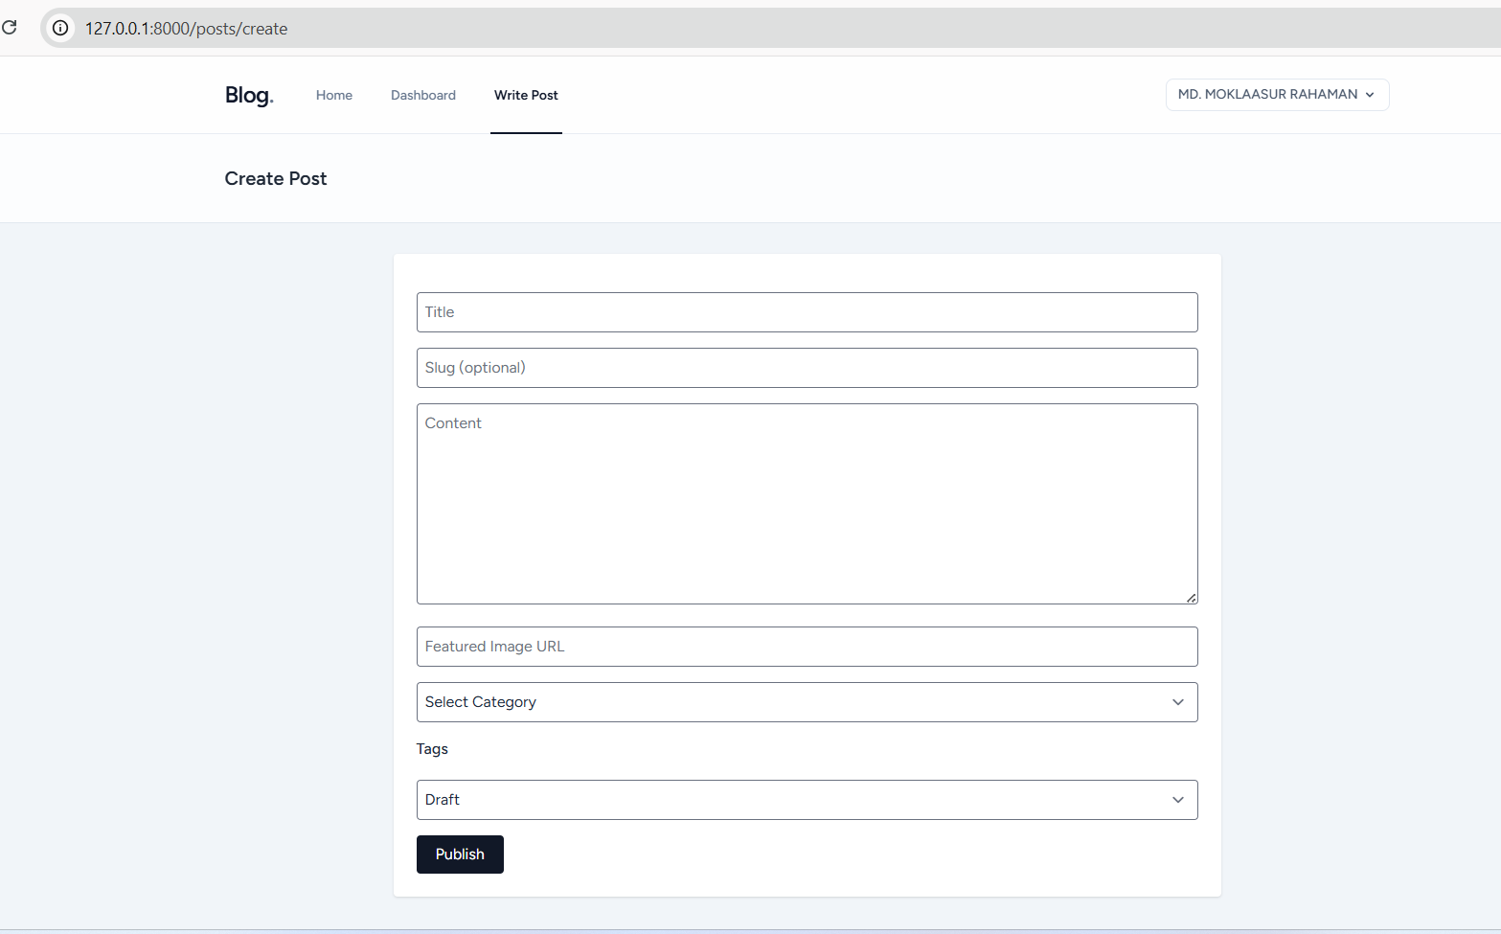
A comprehensive form to handle post title, content, category, and tags.
// PostController.php @store
public function store(Request $request) {
$validated = $request->validate([...]);
$post = Post::create($validated + ['user_id' => auth()->id()]);
$post->tags()->attach($request->tags);
return redirect('/dashboard');
}

Profile & Security
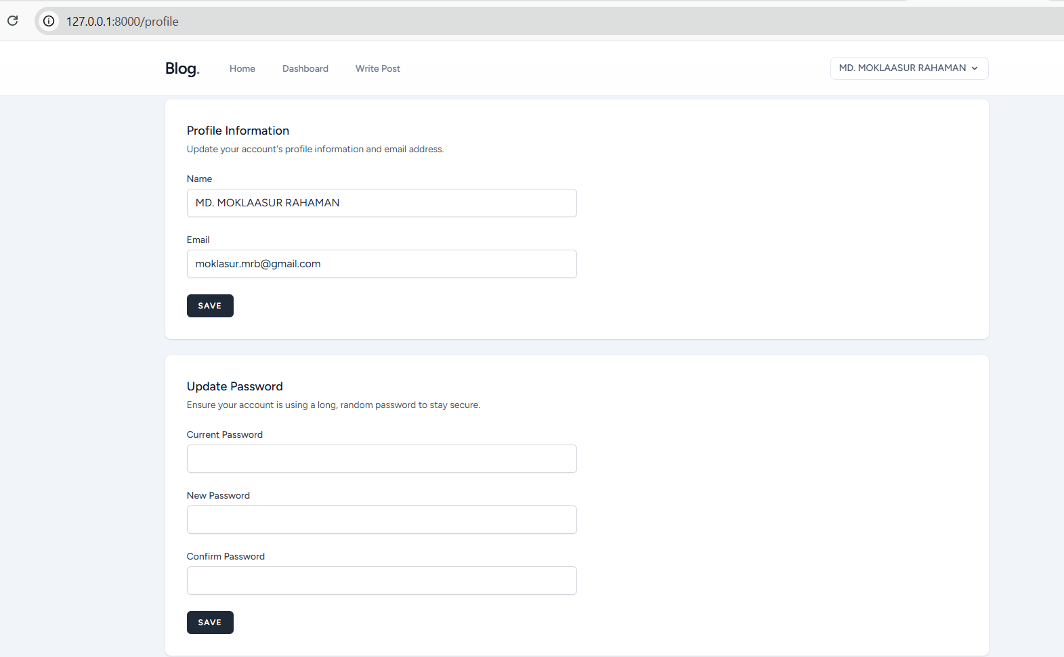Allows users to update their personal information and secure their accounts with new passwords.

<?php
namespace App\Http\Controllers;

use App\Http\Requests\ProfileUpdateRequest;
use Illuminate\Http\RedirectResponse;
use Illuminate\Http\Request;
use Illuminate\Support\Facades\Auth;
use Illuminate\Support\Facades\Redirect;
use Illuminate\View\View;

class ProfileController extends Controller
{
/**
* Display the user's profile form.
*/
public function edit(Request $request): View
{
return view('profile.edit', [
'user' => $request->user(),
]);
}

/**
* Update the user's profile information.
*/
public function update(ProfileUpdateRequest $request): RedirectResponse
{
$request->user()->fill($request->validated());

if ($request->user()->isDirty('email')) {
$request->user()->email_verified_at = null;
}

$request->user()->save();

return Redirect::route('profile.edit')->with('status', 'profile-updated');
}

/**
* Delete the user's account.
*/
public function destroy(Request $request): RedirectResponse
{
$request->validateWithBag('userDeletion', [
'password' => ['required', 'current_password'],
]);

$user = $request->user();

Auth::logout();

$user->delete();

$request->session()->invalidate();
$request->session()->regenerateToken();

return Redirect::to('/');
}
}

Database Architecture
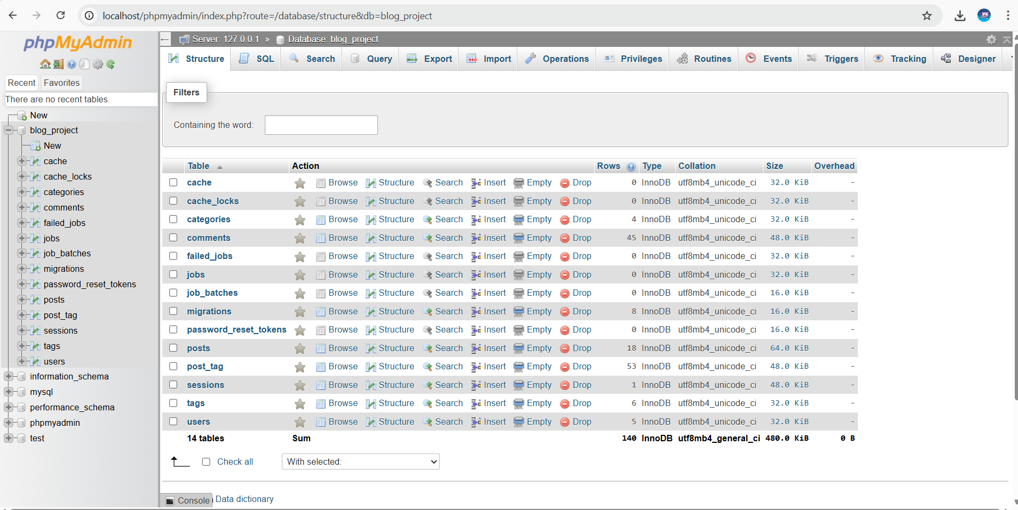
Database Schema (Migrations):
Schema::create('posts', function (Blueprint $table) {
$table->id();
$table->foreignId('user_id')->constrained()->onDelete('cascade');
$table->string('title');
$table->text('content');
$table->enum('status', ['draft', 'published']);
$table->timestamps();
})
;

Installation & Setup

To run this project locally, use the following commands:
composer install
npm install
php artisan migrate --seed
npm run build
php artisan serve

© 2026 Laravel Blog Project - MD. MOKLAASUR RAHAMAN

